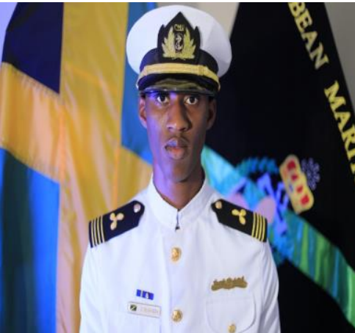

JAVIER D. RICHARDS
Marine Engineer Cadet

Rural Retreat, Claremont P.O., St. Ann, Jamaica W.I.
Email: javierrichards73@gmail.com
Tel: 1 (876) 451-7040

CAREER SUMMARY
Problem solver with progressive leadership, technical and communication skills. Proven ability to complete multiple projects within given deadlines. Dedicated to acquiring industry knowledge in the field of Marine Engineering, while assisting in the operations of the organization.

EDUCATION
Caribbean Maritime University, Palisadoes Park, Kingston 2018- 2022
- Bachelor of Science Degree in Marine Engineering (2018-2022)
- Associates Degree in Marine Engineering (2018-2020)
Moneague College, Moneague P.O., St Ann 2017-2018
- Caribbean Advanced Proficiency Examination (CAPE)
Ferncourt High School, Claremont P.O., St. Ann 2012-2017
- Caribbean Secondary Education Certificate (CSEC)

WORKSHOPS AND CERTIFICATES
- Ship Security Awareness (STCW)
- Basic Safety Training (STCW)
- Proficiency in Crowd and Crisis Management and Human Behaviour (STCW)
- Basic Liquefied Gas Tanker Cargo Operations (STCW)
- Basic Training for Oil and Chemical Tanker (STCW)
- Ellis and Associates Lifeguard certificate (2021 - 2022)
- Emergency First Aid and Safety Training (Including Paediatric First Aid)

ACHIEVEMENTS
- Training Instructor of the Caribbean Maritime University Sailing Team third place winners in 2019.
- Assigned Indoctrinator to first-year and second-year cadets and Division Commander for the Marine and Nautical studies program at Caribbean Maritime University
- Deans Honour Roll
- Class of 2022 graduate with Honours

EXTRA-CURRICULAR AND VOLUNTARY ACTIVITIES
- Sailing at Loose Cannon Tours and Lime Cay Tours.
- Member of the Caribbean Maritime University Corp of Drums.
- Caribbean Maritime University Sailing Team.
- Served as Camp Counsellor for North Jamaica Conference of the Seventh Day Adventist Church.
- Developed a Youth Federation Programme to teach community members Technical and Computation skills.
- Served as Deputy Chair at U.C.I Jamaica Foundation.
WORK HISTORY
Exmar Ship Management April 2023 – Present
- Engine Cadet (18 months seagoing service)
Caribbean Maritime University, Maritime Training Centre, November 2022 – Present
Kingston (Part-time)
- Part time Assistant Training Instructor for Basic Safety Training
Continental Pools, Savage, Maryland May – September 2022
- Lifeguard
Rural Agricultural Development Authority, Claremont P.O, St Ann 2018
- Acted as a Security Guard.
- Acted as an Office Assistant
Great Pond Basic School, Ocho Rios P.O, St Ann 2016
- Assistant Teacher
Claremont Parish Library, Claremont P.O., St. Ann 2016
- Acted as an Assistant Librarian

SKILLS LANGUAGES
- Auto CAD
English - Native
Spanish - Beginner
Flexible
Adaptable
- Sailing
- Microsoft Suite

REFERENCES
Pastor Renardo Campbell
Minister of Religion
Greenwich Estate, Lot 19
St. Ann’s Bay P.O.,
St. Ann
876- 485-8443
renardocampbell@gmail.com

Ms. Renee’ Soocka
Lot 596 Ginger Lilly Close
Eltham View Spanish Town
876-836-6454
rsoocka@cmu.edu.jm

