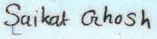
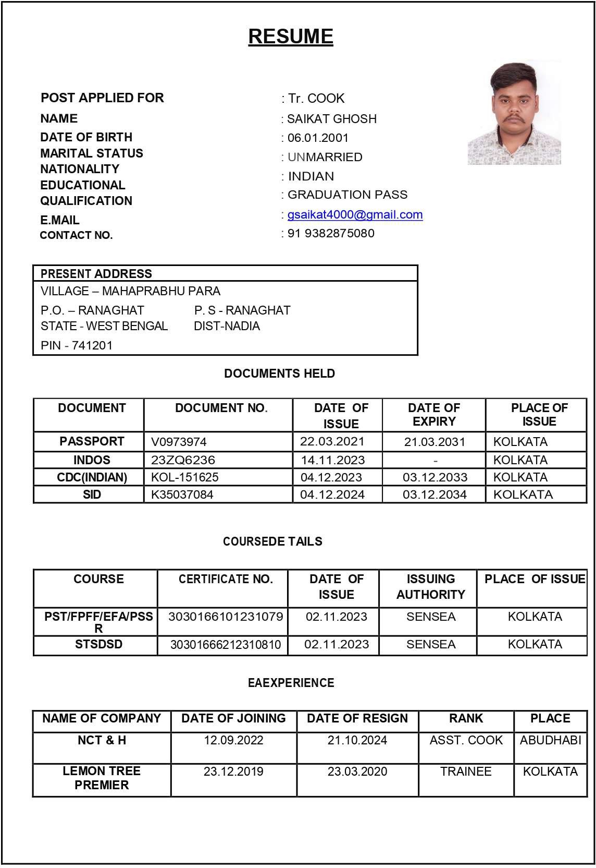
Date: 27.04.2025
Place: RANAGHAT Signature

