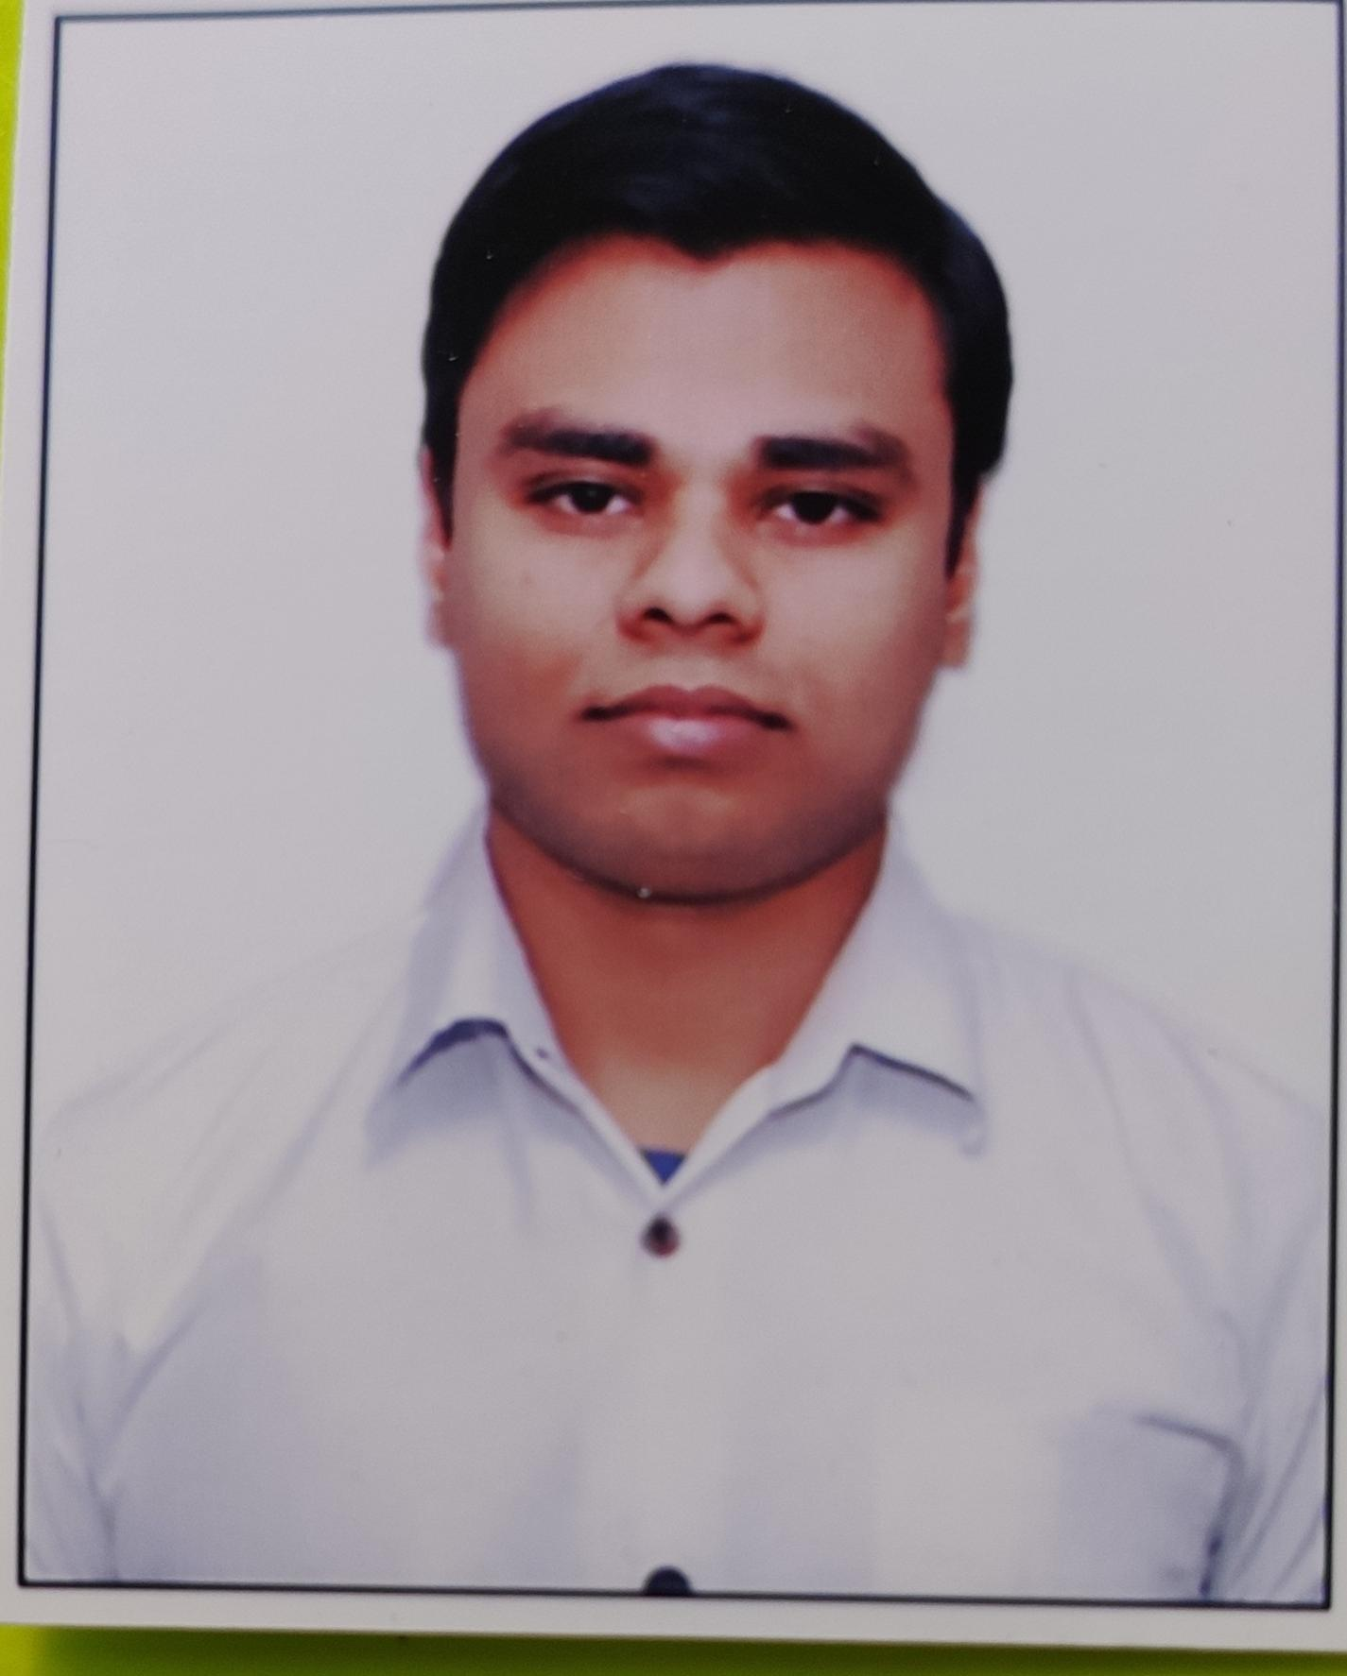 |  |  | Dipankar maity  Experience  I have an experience of 18 months and I am currently working there as Captain Waiter in JP shiddharth Hotel.  - Greeted guests and provided them with menus.  - Assigned seating arrangements for guests.  - Ensured a smooth flow of service in the restaurant.  - Informed customers about daily specials.  - Verified guest satisfaction with meals and suggested additional items to increase restaurant sales.  Education  Graduation from Amity University Kolkata  - Bachelor in Hotel Management  Summary  Adaptable worker familiar with FOH and BOH operations. Hardworking collaborator with background providing exceptional customer service and friendly food service to ensure guest satisfaction.  Responsible with 17 months of experience in fast-paced service settings. Systematic about taking accurate orders, keeping customers happy and supporting team success. Quickly clears and resets tables, restocks supplies and cleans up spills.  Languages  - Hindi  - English  Skills  - Menu knowledge  - Table Setting  - Allergy awareness  - Order Taking  - Team Management
 | India, New Delhi
 | +91 8447651994
 | deepankor maity0714@gmail.com

Objective
My objective is to gain more knowledge and skills in my profession so that I can improve my self and provide knowledge to others as well and keep moving forward in my profession.

