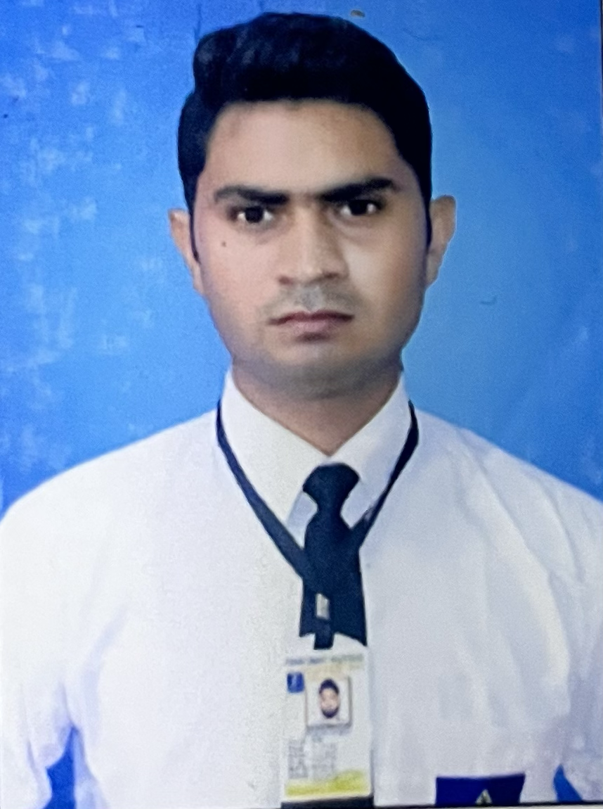
Jitendra Kumar
NAGLA BARAULA BYE
PASS ROAD ALIGARH
202001
Contact No.- +91-9870966066
Email: jitendrakumar341441@gm
ail.com

CAREER OBJECTIVE
Individual with strong passion for hospitality business Bachelor’s degree in Hospitality
Management, looking to obtain a Hotel Management position to hone my skills as well as
contribute to the highest quality of service at the hotel.

EXPERIENCE

● Currently working in SHANGRI-LA EROS NEW DELHI (from MAy 2022 to till
date)

Responsibilities:

∙ Handling Housekeeping desk operations, guest interactions and queries.
∙ Work with Front Desk and Maintenance Departments regarding the status of
rooms and common areas ensuring that guest requirements are met
according to Hotel policy.
• Report and assign work assignment to Housekeepers
according to their sections.

• Responsible for supporting the Housekeeping
department for administrative duties.
• Checks the key cabinet at the end of each shift to
make sure that all keys allocated to housekeeping
recounted for, mobile phones.
• To ensure that the notice board is updated correctly at
all times.

Work at The Leela Ambience Gurugram (from Aug 2021 to Apr 2022)

Responsibilities:

∙ Taking care of guest room and providing high level of housekeeping service
in terms of cleanliness, hygiene, security, comfort and making guest to feel at
home.
∙ Work with Front Desk and Maintenance Departments regarding the status of
rooms and common areas ensuring that guest requirements are met
according to Hotel policy.
∙ Scheduling the periodic major cleaning includes carpet shampooing, high
level cleaning, cleaning of window glasses, etc.

EDUCATIONAL QUALIFICATIONS

∙ Accommodation Operation and Management from Food Craft Institute in 2020.
∙ B.com from Dr. Bhimrao Ambedkar University Agra in 2019
∙ Passed Intermediate from UP board in 2016.
∙ Passes High School from UP board in 2014.

INTERNSHIP

● 24 Weeks training program with Le Meridian Jaipur Resort and Spa
(from Oct 2020 to Mar 2021)

COMPUTER KNOWLEDGE

∙ Opera basics
∙ Basic Computer knowledge

I hereby declare that the information provided in this document is true and to the best of
my knowledge.

Place: Date:

