ALEX ALEXANDER 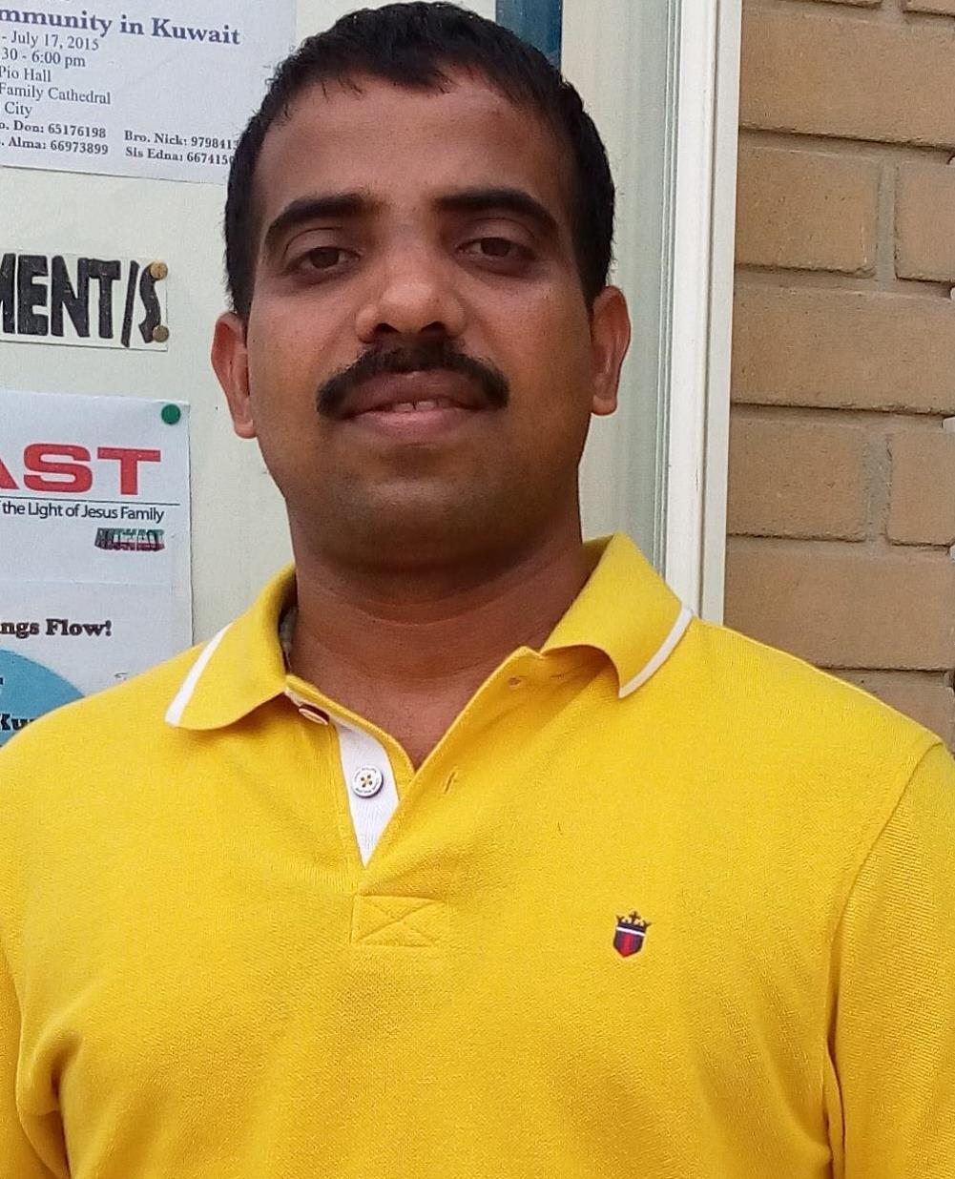

Kattumpurath House, Mathirapilly Road, P.O. South Chittoor, Edayakunnam-682027, Kerala, India.
Mobile No: +91 8848349075, Email ID: alexalexander394@gmail.com
Position Applied For:
Commis 1

Career Objective:
To gain the position of as Commis 1utilizing my professional experience and skills towards providing excellent service.
Summary of Skills:
Comprehensive knowledge of Commis 1 and attention to detail Self-motivated organized with good manual dexterity Ability to stand for long hours and Possess good judgment skills and has the ability to juggle multiple tasks at one time in the food service.

Personal Information:

- Father’s Name : late.K.A. Alexander
- Nationality : Indian
- Date of Birth : 20/Feb/1976
- Marital Status : Single
- Sex : Male
- Religion : Catholic, Christian
- Hobbies : Interacting with Peoples, Travelling, Jogging, and
Listening Music.
- Language Known : Malayalam, Hindi, Tamil, English, Arabic

Pass Port Details:

- Pass Port Number : T 6756722
- Date of Issued : 22.08.2019
- Date of Expired : 21.08.2029
- Place of Issued : Kuwait.

Educational Qualification:

- S.S.L.C from St. Albert’s School Cochin, Kerala.

Technical Qualification:

- Completed one Year Diploma in Hotel Management Kerala India.

Certificates for Food Safety:

- Serve Safe KBR (USA) Food Service Sanitation and Food Safety Baghdad Iraq.
- Supreme Food Service Training for US. Army Food Safety Kabul Afghanistan.
- First Aid Training, CPR Certificate from OSHO Kingdom of Bahrain.
- Fundamentals of Fire Extinguisher Use and Safety from Wackenhut Services Inc USA Baghdad Iraq 2004.

Excellent Achievement Award:

Six years Service Winner Award with Renaissance Catering US Army Base Baghdad Iraq from 2003 to 2009.

Work Experience in Gulf:

- One Years of Experience in Army Base Kuwait as Demy Chef de Partie.
- Seven years of Experience in Army Base Kuwait as Senior Cook.
- Two Years of Experience in Royal Police Base Bahrain as Cook.
- One Year Experience in Supreme Food Service US. Marines Base Kabul Afghanistan as Asst. Cook
- Six Years of Experience in Renaissance Catering Company US. Army Base Baghdad Iraq as Junior Cook.

Work Experience in India:

- Five Months Training Experience in Hotel Taj Residency 5 Star Ernakulum as Trainee Cook.
- Two Years Experience in Hotel Gogulam Park Inn 4 Star Delux as Cook Apprentice .

If given an opportunity I will endeavor to give the best possible effort for the organization.

Place: Kochi ---------------
Date: 09/11/23 ALEX ALEXANDER

