Job

Experiences


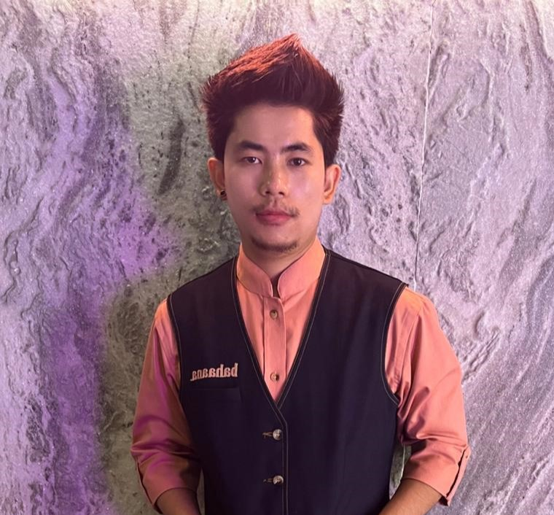

- CAPTAIN
BAHAANA BAR AND RESTAURANNT BELAPUR
From MARCH 2023 TO CURRENT DATE
- CAPTAIN
THE UNION BAR AND EATING HOUSE VASHI
VASHI FROM 2017 to 2023

SAFAL SUBBA

Career Objective
Intend to build career with a leading corporate company having a hi-tech environment consisting of committed and dedicated people, which will help me to explore myself fully and realize my potential and to work as a productive affiliate with an organization which will provide the ambience and opportunity for my personal and professional growth.

- 12th WEST BENGAL STATE BOARD

Education

Personal Details

DOB : 30 August 1996
Gender : Male
Marital Status : Unmarried
Religion : Hindu
Contact Details

KARMATAR BUSTY GOKE DARJEELING WEST BENGAL 734201

+91 7864004521, 8779213295

Safalsubba19@gmail.com



Languages

ENGLISH
NEPALI
HINDI

Soft Skill
Strong Work Ethics
Team Work
Positive attitude
Problem Solving
self-motivated

