PROFILE

 8178471524
 ishananand43@gmail.com
 A-32 DLF DILSHAD PLAZA EXTN-II GAZIABAD
BIRTH DATE
03rd AUGUST 2000
Father's Name - Mr Rajendra Kumar Anand
Sex - Male
Age - 23 year's
NATIONALITY
Indian
LANGUAGES
English
Hindi
SKILLS
Flexible & Adaptable
Fast Learner
Computer Skills
Leadership
Team work
Pressure Handling
Decision making
Hardworking and passionate jobseeker with strong organizational skills eager to secure position in organization.Ready to help team achieve company goals.
ISHAN ANAND
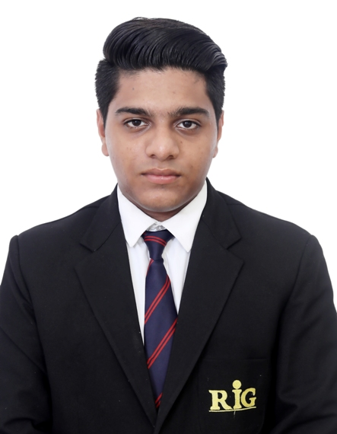

EDUCATION
B.Sc in Hospitality and Hotel Administration
2019-2022
From IHM RIG INSTITUTE OF HOSPITALITY AND MANAGEMENT,
Greater Noida
Intermediate, CBSE BOARD
2018 From Dashmesh Public School, Vasundhara Enclave
High School, CBSE BOARD
2016 From Dashmesh Public School, Vivek Vihar
Work Experience
Industrial Training from Le Meridien, New Delhi in 2021
Worked as a GSA joined in Vivanta by Taj Ahemdabad pre-opening, INDIA 1 year and 7 months (May 2022 - November 2023 )
Worked as a Housekeeping Supervisor in Vivanta by Taj Ahemdabad, India ( November 2023- January 2024)
Worked as an Housekeeping Executive in Pre-Opening property Katra, Marriott Resorts & Spa, Jammu & Kashmir India from ( January 2024 - September 2024 )
Currently working as an Housekeeping Executive in Leela Ambience hotel & Residence Gurugram ( September 2024 - Presently )

AREA OF INTEREST
House Keeping
JOB DISCRIPTION
Housekeeping Executive
Responsible for Maintaining Cleaneness and sanitizes hotel and guest rooms.
Responsible for Staff Allocation and Roaster
Responsible for Taking Staff Trainings as per SOP
Responsible for Inventories
Responsible for Smooth functioning of Department
Responsible for Maintaining Decorum and Discipline within the Department

ACHIEVEMENT
Got 1st rank in IHCL FITNEES challenge
Recognition on TripAdvisor
Awarded for Exemplary contribution at VIVANTA AHEMDABAD by IHC LONDON AND IIHM INTERNATIONAL HOSPITALITY For FY- 2022-23
Appreciation Certificate for being a part of pre opening team of Katra Marriott Resorts & spa. 150th Marriott hotel in India
HOBBY
Listening to music
Travelling
Writing Poetry
Extra Curricular Activities
Blood Donation
Cleaning Drive
Visiting Old age home
REFERENCE
Mr Nitesh Singh -" Taj SKYLINE Ahemdabad "
HOD ( DEPUTY HOUSEKEEPER)
Email- singh.nitesh@tajhotels.com
9669885580

Declaration
I solemnly declare that the information in this resume is true to the best of my knowledge and belief. All information in this resume is right and truthful.I take full liability for the correctness of the information.

